SAULT COLLEGE OF APPLIED ARTS AND TECHNOLOGY

SAULT STE. MARIE, ONTARIO



COURSE OUTLINE

COURSE TITLE: | Data Analysis and Presentation
CODE NO. : | NET 150 |  | SEMESTER: | 2
PROGRAM: | Natural Environment Technician/Technologist
AUTHOR: | Rob Routledge (modified after V. Walker, 2013)
DATE: | Jan. 2014 | PREVIOUS OUTLINE DATED: |  |  | Jan. 2013
APPROVED: | “C. Kirkwood” |  |  |  | Jan.’14
 | ____________________________  DEAN |  |  |  | ___________  DATE
TOTAL CREDITS: | 2
PREREQUISITE(S): | NONE
HOURS/WEEK: | 2

Copyright ©2014 The Sault College of Applied Arts & Technology
Reproduction of this document by any means, in whole or in part, without prior

written permission of Sault College of Applied Arts & Technology is prohibited.

For additional information, please contact Colin Kirkwood,
Dean, Environment/Design/Business,
School of Environment and Technology
(705) 759-2554, Ext. 2688

I. | COURSE DESCRIPTION:  This course provides students with an introduction to statistics and experience using the spreadsheet program Microsoft Excel to enter and manipulate data, generate descriptive statistics, create tables and graphs, and conduct basic inferential statistics. In addition, students will learn how to use PowerPoint as an effective visual communication tool and will continue to build upon their technical report writing skills through the interpretation of results from meaningful tables, graphs or analyses generated in Excel. Field data collection and management skills will be further developed along with the use of GPS receivers to collect spatial data (e.g., track logs, plot locations) and transfer it to Google Earth.
II. | LEARNING OUTCOMES AND ELEMENTS OF THE PERFORMANCE:
 | Upon successful completion of this course, the student will demonstrate the ability to:
 | 1. | Use PowerPoint to design an effective slide show and large format poster presentation.
Potential Elements of the Performance:

- Discuss the advantages and limitations of using a PowerPoint slide show as an effective visual communication tool
- Define criteria which contribute to an effective poster presentation and PowerPoint slide show and establish “rules” to guide their preparation
- Use text, images, charts, etc. to create an effective PowerPoint slide show and poster presentation using established “rules”

 | 2. | Introduction to elementary statistics.
Potential Elements of the Performance:

- Define and distinguish between qualitative and quantitative data
- Describe the differences and strengths and weaknesses among the four levels of measurement: nominal (categorical), ordinal (rank order), interval, and ratio
- Define and distinguish between discrete and continuous variables
- Understand how descriptive statistics can be used to explore field data:
  - measures of central tendency (mean, median, mode)
  - measures of variability (range, interquartile range, standard deviation, variance)
  - skewness
  - tables and graphs (e.g., frequencies or percentages)
  - associations between two or more variables (contingency tables for categorical variables; scatterplots and correlation for quantitative variables)
- Understand concepts underlying inferential statistics (e.g., standard error of the mean, null and alternative hypotheses, tests of significance, Type I and Type II errors, one-tailed and two-tailed tests, degrees of freedom, tests of significance)
- Identify types of measurement error (random vs. systematic), ways to reduce measurement error, and how the type and extent of measurement error relate to precision and accuracy
- Demonstrate proficiency in measurement unit conversions (i.e., within and between english and metric systems)

 | 3. | Introduction to spreadsheet program (Microsoft Excel) for the purposes of data entry and organization of data.  Potential Elements of the Performance:  - Demonstrate ability to:  - set up an Excel spreadsheet to accommodate data entry (e.g., create column headers to organize data into discrete records, create dropdown lists, embed data validation)  - load raw data from tally sheets and from established data sets  - utilize the data form feature to enter additional data to a spreadsheet  - utilize the database capabilities of Microsoft Excel to sort, filter and organize raw data sets in a meaningful way
 | 4. | Collect, analyze, interpret, and summarize natural resource-based field data.
Potential Elements of the Performance:

- Demonstrate proficiency in field data collection and management and use of GPS receivers to collect spatial data (e.g., track logs, plot locations) and transferring it to Google Earth
- Demonstrate ability to use the data analysis tools available in Microsoft Excel
  - use descriptive statistics to explore data
  - use basic parametric and non-parametric inferential statistics
- Prepare graphs and tables using Microsoft Excel to summarize descriptive data and statistical analyses
- Prepare a technical report interpreting results from meaningful tables, graphs, and statistical analyses generated in Microsoft Excel
III. | TOPICS:  - qualitative and quantitative data  - levels of measurement (nominal, ordinal, interval, and ratio)  - discrete and continuous variables  - use of descriptive statistics to explore field data  - measurement unit conversions  - concepts underlying inferential statistics  - statistical terminology  - data entry and organization in Microsoft Excel  - tabular and visual display of data  - Microsoft PowerPoint  - slide show  - poster presentation  - technical report writing  - GPS receivers
IV. | REQUIRED RESOURCES/ TEXTS/ MATERIALS:  - USB flash drive  - scientific calculator  - All reference material will be placed on LMS (D2L)
V. | EVALUATION PROCESS/GRADING SYSTEM:  - Tests 30%  - Assignments 70%  - To be eligible to make up for a missed test or quiz, the instructor must be contacted via phone or email ASAP to discuss make-up options. Students not contacting the instructor prior to a missed class or within a day afterwards will get a zero except under extenuating circumstances; e.g., doctor’s note.  - Late assignments will only be accepted within 24 hours past the due date and will be penalized 20% except under extenuating circumstances, e.g., doctor’s note  - The instructor cannot guarantee responses to questions in the 24-hour period prior to assignment deadlines and tests via phone message or email.
 | 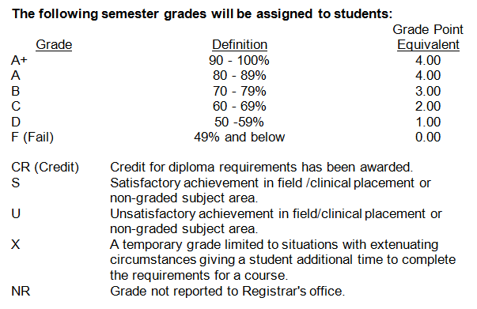
VI. | SPECIAL NOTES:
- Any student who in the judgement of the instructor behaves inappropriately in scheduled classes or copies the work of another student without the instructor’s permission, will be subject to all the terms and conditions in the Student Code of Conduct hand book (see MySaultCollege portal) and may after, reviewing the situation with the instructor, be asked to leave the course with an F grade.

- Sault College is committed to student success. There is a direct correlation between academic performance and class attendance; therefore, for the benefit of all its constituents, all students are encouraged to attend all of their scheduled learning and evaluation sessions. This implies arriving on time and remaining for the duration of the scheduled session.

- The Instructor reserves the right to change the information contained in this course outline depending on the needs of the learner and the availability of resources.

- If you are a student with special needs (e.g. physical limitations, visual impairments, hearing impairments, or learning disabilities), you are encouraged to discuss required accommodations with your instructor and/or the Special Needs office.

.

